Joins in sql server
In a relational database, data is distributed in multiple logical tables. To get a complete meaningful set of data, you need to query data from these tables using joins. SQL Server supports many kinds of joins, including inner join, left join, right join, full outer join, and cross join. Each join type specifies how SQL Server uses data from one table to select rows in another table.
Let’s set up sample tables for demonstration.

Setting up sample tables
First, create a new schema named hr:
CREATE SCHEMA hr;
GOCode language: SQL (Structured Query Language) (sql)
Second, create two new tables named candidates and employees in the hr schema:
CREATE TABLE hr.candidates(
id INT PRIMARY KEY IDENTITY,
fullname VARCHAR(100) NOT NULL
);

CREATE TABLE hr.employees(
id INT PRIMARY KEY IDENTITY,
fullname VARCHAR(100) NOT NULL
);
Code language: SQL (Structured Query Language) (sql)
Third, insert some rows into the candidates and employees tables:
INSERT INTO
hr.candidates(fullname)
VALUES
('John Doe'),
('Lily Bush'),
('Peter Drucker'),
('Jane Doe');

INSERT INTO
hr.employees(fullname)
VALUES
('John Doe'),
('Jane Doe'),
('Michael Scott'),
('Jack Sparrow');
Code language: SQL (Structured Query Language) (sql)
Let’s call the candidates table the left table and the employees table the right table.

SQL Server Inner Join
Inner join produces a data set that includes rows from the left table, and matching rows from the right table.
The following example uses the inner join clause to get the rows from the candidates table that has the corresponding rows with the same values in the fullname column of the employees table:
SELECT
c.id candidate_id,
c.fullname candidate_name,
e.id employee_id,
e.fullname employee_name
FROM
hr.candidates c
INNER JOIN hr.employees e
ON e.fullname = c.fullname;Code language: SQL (Structured Query Language) (sql)
Here is the output:
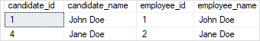
The following Venn diagram illustrates the result of the inner join of two result sets:
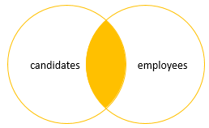

SQL Server Left Join
Left join selects data starting from the left table and matching rows in the right table. The left join returns all rows from the left table and the matching rows from the right table. If a row in the left table does not have a matching row in the right table, the columns of the right table will have nulls.
The left join is also known as the left outer join. The outer keyword is optional.
The following statement joins the candidates table with the employees table using left join:
SELECT
c.id candidate_id,
c.fullname candidate_name,
e.id employee_id,
e.fullname employee_name
FROM
hr.candidates c
LEFT JOIN hr.employees e
ON e.fullname = c.fullname;Code language: SQL (Structured Query Language) (sql)
Here is the output:
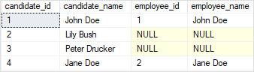
The following Venn diagram illustrates the result of the left join of two result sets:
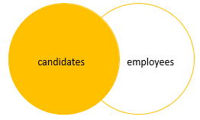
To get the rows that are available only in the left table but not in the right table, you add a WHERE clause to the above query:
SELECT
c.id candidate_id,
c.fullname candidate_name,
e.id employee_id,
e.fullname employee_name
FROM
hr.candidates c
LEFT JOIN hr.employees e
ON e.fullname = c.fullname
WHERE
e.id IS NULL;
Code language: SQL (Structured Query Language) (sql)
The following picture shows the output:
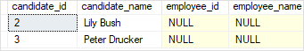
The following Venn diagram illustrates the result of the left join that selects rows available only in the left table:
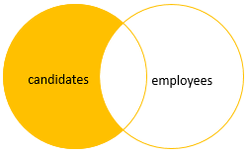

SQL Server Right Join
The right join or right outer join selects data starting from the right table. It is a reversed version of the left join.
The right join returns a result set that contains all rows from the right table and the matching rows in the left table. If a row in the right table does not have a matching row in the left table, all columns in the left table will contain nulls.
The following example uses the right join to query rows from candidates and employees tables:
SELECT
c.id candidate_id,
c.fullname candidate_name,
e.id employee_id,
e.fullname employee_name
FROM
hr.candidates c
RIGHT JOIN hr.employees e
ON e.fullname = c.fullname;
Code language: SQL (Structured Query Language) (sql)
Here is the output:
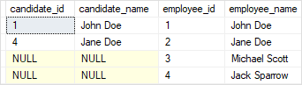
Notice that all rows from the right table (employees) are included in the result set.
The Venn diagram illustrates the right join of two result sets:
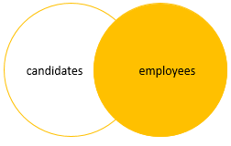
Similarly, you can get rows that are available only in the right table by adding a WHERE clause to the above query as follows:
SELECT
c.id candidate_id,
c.fullname candidate_name,
e.id employee_id,
e.fullname employee_name
FROM
hr.candidates c
RIGHT JOIN hr.employees e
ON e.fullname = c.fullname
WHERE
c.id IS NULL;
Code language: SQL (Structured Query Language) (sql)
Here is the output:
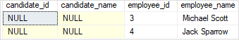
And the Venn diagram that illustrates the operation:
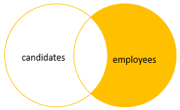

SQL Server full join
The full outer join or full join returns a result set that contains all rows from both left and right tables, with the matching rows from both sides where available. In case there is no match, the missing side will have NULL values.
The following example shows how to perform a full join between the candidates and employees tables:
SELECT
c.id candidate_id,
c.fullname candidate_name,
e.id employee_id,
e.fullname employee_name
FROM
hr.candidates c
FULL JOIN hr.employees e
ON e.fullname = c.fullname;
Code language: SQL (Structured Query Language) (sql)
Here is the output:
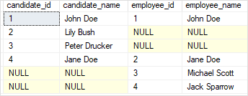
The Venn diagram that illustrates the full outer join:
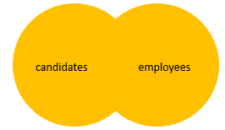
To select rows that exist in either the left or right table, you exclude rows that are common to both tables by adding a WHERE clause as shown in the following query:
SELECT
c.id candidate_id,
c.fullname candidate_name,
e.id employee_id,
e.fullname employee_name
FROM
hr.candidates c
FULL JOIN hr.employees e
ON e.fullname = c.fullname
WHERE
c.id IS NULL OR
e.id IS NULL;
Code language: SQL (Structured Query Language) (sql)
Here is the output:
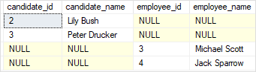
The Venn diagram illustrates the above operation:
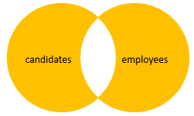
In this tutorial, you have learned various SQL Server joins that combine data from two tables.
888888888888888888888888888888888
SQL Server Joins

What is a Join?
- A JOIN in SQL Server combines rows from two or more tables based on a related column.
- Purpose: To query meaningful data spread across multiple tables.
- Common join types:
  - INNER JOIN
  - LEFT JOIN
  - RIGHT JOIN
  - FULL OUTER JOIN
  - CROSS JOIN
  - SELF JOIN

Example Tables
Let’s assume we have three tables:
CREATE TABLE Customers (
CustomerID INT PRIMARY KEY,
Name VARCHAR(50)
);

CREATE TABLE Orders (
OrderID INT PRIMARY KEY,
CustomerID INT,
ProductID INT
);

CREATE TABLE Products (
ProductID INT PRIMARY KEY,
ProductName VARCHAR(50),
Price DECIMAL(10,2)
);

Sample Data
INSERT INTO Customers VALUES (1, 'Alice'), (2, 'Bob'), (3, 'Charlie');
INSERT INTO Products VALUES (101, 'Laptop', 1200), (102, 'Phone', 800), (103, 'Tablet', 500);
INSERT INTO Orders VALUES (1001, 1, 101), (1002, 2, 102), (1003, 2, 103);

Types of Joins Explained with 3 Tables

1. INNER JOIN
- Returns rows where there is a match in both tables.

SELECT c.Name, p.ProductName, p.Price
FROM Customers c
INNER JOIN Orders o ON c.CustomerID = o.CustomerID
INNER JOIN Products p ON o.ProductID = p.ProductID;
Result:
- Alice → Laptop
- Bob → Phone, Tablet
(Charlie has no orders, so excluded)

2. LEFT JOIN
- Returns all rows from the left table, even if no match in the right.
SELECT c.Name, p.ProductName
FROM Customers c
LEFT JOIN Orders o ON c.CustomerID = o.CustomerID
LEFT JOIN Products p ON o.ProductID = p.ProductID;
Result:
- Alice → Laptop
- Bob → Phone, Tablet
- Charlie → NULL (no orders)

3. RIGHT JOIN
- Returns all rows from the right table, even if no match in the left.
SELECT c.Name, p.ProductName
FROM Customers c
RIGHT JOIN Orders o ON c.CustomerID = o.CustomerID
RIGHT JOIN Products p ON o.ProductID = p.ProductID;
Result:
- Alice → Laptop
- Bob → Phone, Tablet
(If there were orders without customers, they’d still appear)

4. FULL OUTER JOIN
- Returns all rows when there is a match in either left or right table.
SELECT c.Name, p.ProductName
FROM Customers c
FULL OUTER JOIN Orders o ON c.CustomerID = o.CustomerID
FULL OUTER JOIN Products p ON o.ProductID = p.ProductID;
Result:
- Alice → Laptop
- Bob → Phone, Tablet
- Charlie → NULL
- Any unmatched products/orders also appear

5. CROSS JOIN
- Returns Cartesian product (all combinations).
SELECT c.Name, p.ProductName
FROM Customers c
CROSS JOIN Products p;
Result:
- Alice → Laptop, Phone, Tablet
- Bob → Laptop, Phone, Tablet
- Charlie → Laptop, Phone, Tablet

6. SELF JOIN
- A table joins itself (useful for hierarchical data).
-- Example: Employees table with ManagerID
SELECT e.Name AS Employee, m.Name AS Manager
FROM Employees e
INNER JOIN Employees m ON e.ManagerID = m.EmployeeID;

Summary
- INNER JOIN: Only matching rows.
- LEFT JOIN: All from left + matches.
- RIGHT JOIN: All from right + matches.
- FULL OUTER JOIN: All rows from both sides.
- CROSS JOIN: Every possible combination.
- SELF JOIN: A table joins itself.

Pros of Joins
- Combine Data Across Tables: Joins let you query related information spread across multiple tables (e.g., customers + orders + products).
- Maintain Normalization: Instead of duplicating data in one table, you can normalize and then use joins to reconstruct relationships.
- Flexible Querying: Different join types (INNER, LEFT, RIGHT, FULL, CROSS) give you control over how to include/exclude data.
- Efficient for Relational Data: SQL Server is optimized for joins, so they’re often faster than writing multiple queries.
- Readable Queries: Joins make complex relationships explicit in a single query.

Cons of Joins
- Performance Issues: Large joins across many tables can be slow, especially without proper indexing.
- Complexity: Queries with multiple joins can become hard to read and debug.
- Risk of Cartesian Products: CROSS JOIN or incorrect join conditions can explode the result set unexpectedly.
- NULL Handling: Outer joins introduce NULL values, which require careful handling in queries and reports.
- Scalability Limits: Joins across very large datasets may not scale well compared to denormalized or NoSQL approaches.

Example with Two Tables

Customers
CustomerID | Name
1 | Alice
2 | Bob
3 | Charlie

Orders
OrderID | CustomerID | Product
101 | 1 | Laptop
102 | 2 | Phone

INNER JOIN
SELECT c.Name, o.Product
FROM Customers c
INNER JOIN Orders o ON c.CustomerID = o.CustomerID;
Result: Alice → Laptop, Bob → Phone (Charlie excluded).

LEFT JOIN
SELECT c.Name, o.Product
FROM Customers c
LEFT JOIN Orders o ON c.CustomerID = o.CustomerID;
Result: Alice → Laptop, Bob → Phone, Charlie → NULL.

RIGHT JOIN
SELECT c.Name, o.Product
FROM Customers c
RIGHT JOIN Orders o ON c.CustomerID = o.CustomerID;
Result: Alice → Laptop, Bob → Phone (Charlie excluded, but if an order existed without a customer, it would still appear).

Key Takeaway
- LEFT JOIN: Keep all rows from the left table, fill in matches from the right.
- RIGHT JOIN: Keep all rows from the right table, fill in matches from the left.
- Pros: Powerful for combining normalized data.
- Cons: Can be slow/complex if misused.

